Business Sciences Review

ISSN : 1112-3818 (print)  EISSN : 2602-5396 (online)  Periodicity: semi-annual  Acceptance rate: 56%  Average time of response: 200 days  Average time of publication after acceptance: 27 days  Year of creation: 2002  country: Algeria  Institution: Higher School of Commercial Studies, HEC Algiers | 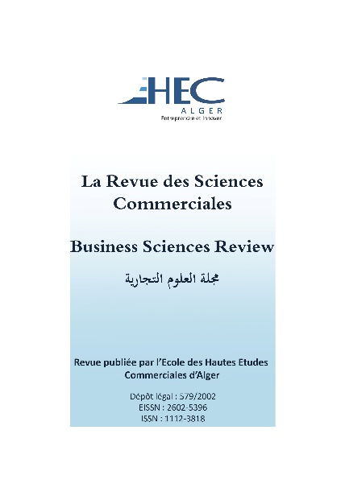
ASJP Link :https://www.asjp.cerist.dz/en/PresentationRevue/360

Description: the business sciences review is a semi-annual review, published in June and December by The Higher School of Commercial Studies, HEC Algiers, since 2002; reading committee; submitted to the procedure of academic evaluation (a double-blind evaluation by two rapporteur). This committee of high international notoriety ensure confidentiality in all the procedures of evaluation that requires examiners who are anonymous, external and do not have the same affiliation to authors who submitted their project article. This review is a sign of vitality of a discipline and it represents a mean of communication and interaction between the members of the academic community and the different actors of the society, the company and the economy. Its ambition is to support the thinking and the debate about all the questions of research in the domain of commercial sciences, economic and management. In this perspective, it favours original contributions, innovative and that reflects recent scientific advances within the framework of conceptual and empirical research respecting the universally recognized norms and academic ethics written in Arabic, French, and English. The review is in both hard copy and electronic version. All the articles are available and downloadable for free in the platform ASJP, without submission and publication fees for the authors. Please refer to our instructions for the authors concerning the articles’ submission in the platform ASJP: https://www.asjp.cerist.dz/en/PresentationRevue/360. For more information or help, please contact us in the email dress: revue.hec@hec.dz

EDITORIAL COMMITTEE
Chief Editor
Hassiba DJEMA
hassiba.djema@hec.dz
The Higher School of Commercial Studies, Algeria.

Associate Editor
Abdelkader HADIR
A.hadir@hec.dz
The Higher School of Commercial Studies, Algeria.

Hichem Sofiane SALAOUATCHI
hs.salaouatchi@hec.dz
The Higher School of Commercial Studies, Algeria.

Marc-Arthur DIAYE
diaye.marc@gmail.com
University Paris 1 Panthéon-Sorbonne, France.
Nicolas MOINET
nmoinet@poitiers.iae-france.fr
IAE of Poitiers, France.
Yvon PESQUEUX
presqueuxyvon@gmail.com
Cnam Paris France.

Bachir MAZOUZ
Bachir.Mazouz@enap.ca
The National School of Public Administration, Canada.

Camal GALLOUJ
gallouj.camal@gmail.com
CEPN Centre for Economics at the University of Paris – North (CEPN), France.

mohamed DJERDJOURI
mdjerdjo@uscupstate.edu
College of Business and Economics at the University of South Carolina, USA.

Azeddine TOUNES
atounes@inseec.com
INSEEC BUSINESS SCHOOL, France.

Mouloud MADOUN
madounmouloud10@gmail.com
Indian Institute of management Trichy, Inde.
Wahiba BALI
wahibakalboussi@yahoo.fr
ISET RADES, TUNISIA
Amar OUKIL
a.r.oukil@googlemail.com
Sultan Qaboos University, Muscat, Oman
Ahsina Khalifa
ahsina.khalifa1@gmail.com
University of Ibn Tofail - Kénitra, Morocco
Issam MALKI
I.Malki@westminster.ac.uk
University of Westminster, UK.
Lylia BAHMED
bahmed_lylia@yahoo.fr
University of Batna 2, Algeria.
Abderrahmane ABEDOU
abder.abedou@gmail.com
CREAD, Algeria.
Hanya KHERCHI MEDJDEN
hanya.kherchi@gmail.com
The National School of statistics and applied economics, Algeria.
Wassila TABET
tabet_wassila@yahoo.fr
University of Aboubeker Belkaid of Tlemcen, Algeria.
Kamila AIT-YAHIA GHIDOUCHE
k.ghidouche-aityahia@hec.dz
The Higher School of Commercial Studies, Algeria.

Secretary

Meriem CHERFOUH
ch.meriem@hotmail.fr
The Higher School of Commercial Studies, Algeria.

Mohand BELKACEMI
m.belkacemi@hec.dz
The Higher School of Commercial Studies, Algeria.

Adress: The Higher School of Commercial Studies, HEC Algiers
University campus Koléa – Tipaza, Algeria.

Contact :
Email: revue.hec@hec.dz
phone: (+213) 24 38 00 36 Fax : (+213) 38 00 35/38 00 38

<p xmlns:dct="http://purl.org/dc/terms/" xmlns:cc="http://creativecommons.org/ns#" class="license-text"><a rel="cc:attributionURL" href="ASJP Link :https://www.asjp.cerist.dz/en/PresentationRevue/360"><span rel="dct:title">Business Sciences Review</span></a> by <span rel="cc:attributionName">DJEMA Hassiba</span>CC BY-NC 4.0<a href="https://creativecommons.org/licenses/by-nc/4.0"><img style="height:22px!important;margin-left: 3px;vertical-align:text-bottom;" src="https://mirrors.creativecommons.org/presskit/icons/cc.svg/?ref=chooser-v1" /><img style="height:22px!important;margin-left: 3px;vertical-align:text-bottom;" src="https://mirrors.creativecommons.org/presskit/icons/by.svg/?ref=chooser-v1" /><img style="height:22px!important;margin-left: 3px;vertical-align:text-bottom;" src="https://mirrors.creativecommons.org/presskit/icons/nc.svg/?ref=chooser-v1" /></a></p>

Business Sciences Review by DJEMA Hassiba is licensed under CC BY-NC 4.0. To view a copy of this license, visit https://creativecommons.org/licenses/by-nc/4.0

Business Sciences Review by DJEMA Hassiba is licensed under CC BY-NC 4.0

